General

This document describes the requirements of the Excel documents to be used for importing 3 types of data into BPR Xplorer, and the modified operation of BPR Xplorer to use these Excel files.

The import processes described below were altered in Nov 2013 so that .xlsx import files can be handled. The system now determines the Excel version that is installed on the PC to see if it is at the level of Excel 2007 SP2 or later. If it is at this level, the system will allow you to select your import file as .XLS or .XLSX, but it will default to .XLSX.

If your Excel is not at the above level you will only be offered .XLS to import

Import Tracking Diaries

2.1 Excel Document

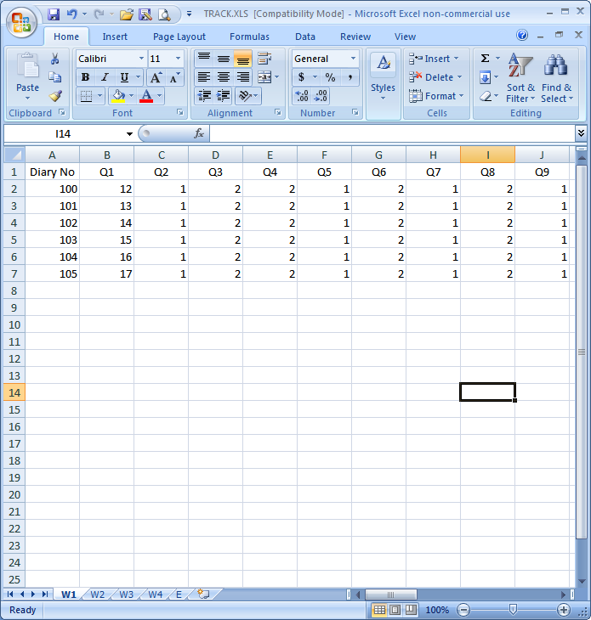

The file TRACK.XLS, must exist in the current data set, and it will comprise between 1 and 5 worksheets, specifically –
- Worksheet W1 must exist and will contain the diary number in column 1 and then the response to BPR Xplorer tracking questions 1 to 250 in columns 2 to 251. It will have an optional heading row as row 1 (see example)

- Worksheet W2 will contain the diary number in column 1 and then the response to BPR Xplorer tracking questions 251 to 500 in columns 2 to 251. It will have an optional heading row as row 1

- Worksheet W3 will contain the diary number in column 1 and then the response to BPR Xplorer tracking questions 501 to 750 in columns 2 to 251. It will have an optional heading row as row 1

- Worksheet W4 will contain the diary number in column 1 and then the response to BPR Xplorer tracking questions 751 to 899 in columns 2 to 150. It will have an optional heading row as row 1

- Worksheet E will contain the diary number in column 1, name in column 2, and telephone number in column 3. It will have an optional heading row as row 1

- Either all or none of the worksheets must use row 1 for headings. If row1 is not used for headings, it must be used for diary information

- The same diary number must exist in the same row of each worksheet

- Diary numbers need not be contiguous, but they must be in ascending sequence, without duplicates.

- Only the number of worksheets required to provide the responses need exist e.g., if you have 400 questions, only worksheets W1 and W2 need exist and worksheet E would be optional

- Worksheets must use the specified names, but can be either upper or lower case. Worksheets using other names will be ignored

Operation

- Import Tracking Diaries is initiated in the normal manner

- A new button Import from an Excel file will appear

- If clicked, the following dialog appears

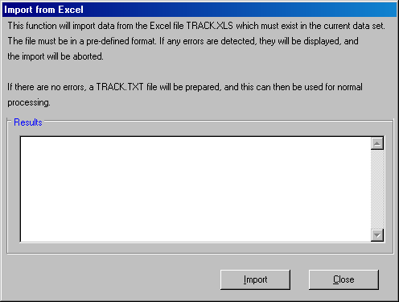

- When the Import button is clicked an attempt is made to process the TRACK.XLS file

- If any errors are found, they are displayed in the Results list box

- If processing is without errors, this is shown in the Results list box, indicating that the TRACK.TXT file has been prepared successfully

- The Close button is then clicked, and then processing (Process button), can be done in the normal manner.

Import Music Diaries

3.1 Excel Document

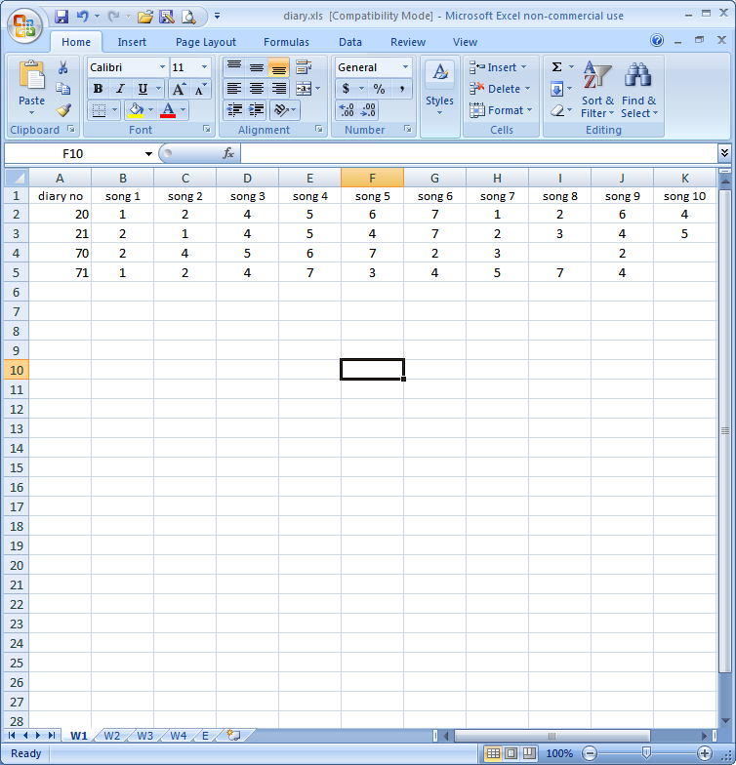

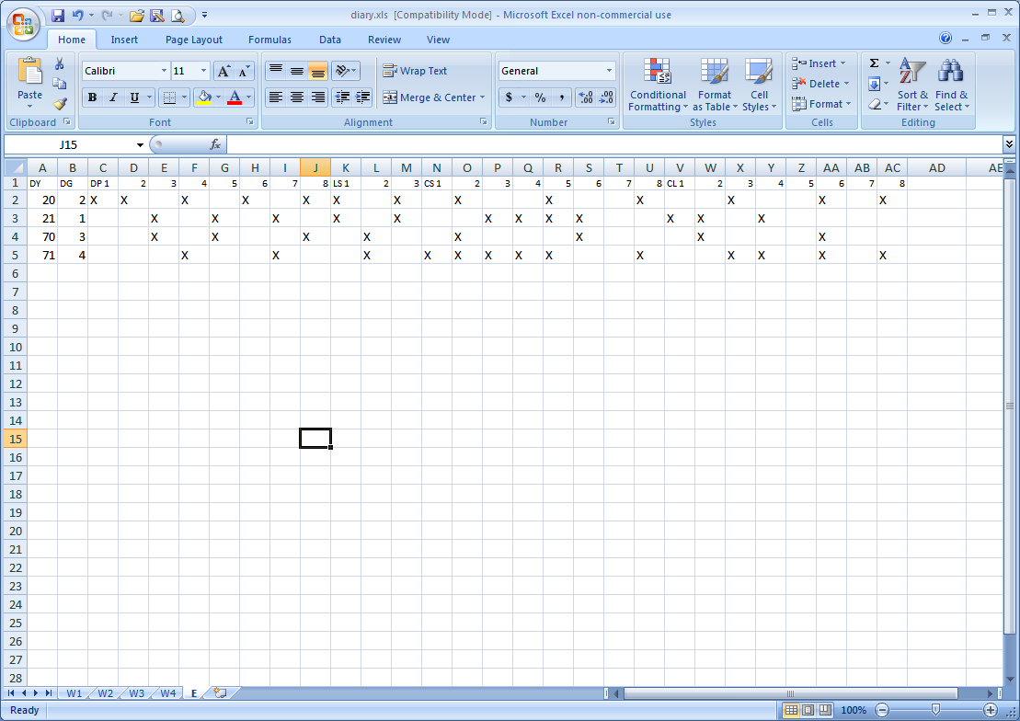

The file DIARY.XLS, must exist in the current data set, and it will comprise between 2 and 5 worksheets, specifically –
- Worksheet W1 must exist and will contain the diary number in column 1 and then the response (blank or 1 to 7) to BPR Xplorer song 1 to 250 in columns 2 to 251. It will have an optional heading row as row 1 (see example)

- Worksheet W2 will contain the diary number in column 1 and then the response to BPR Xplorer song 251 to 500 in columns 2 to 251. It will have an optional heading row as row 1

- Worksheet W3 will contain the diary number in column 1 and then the response to BPR Xplorer song 501 to 750 in columns 2 to 251. It will have an optional heading row as row 1

- Worksheet W4 will contain the diary number in column 1 and then the response to BPR Xplorer song 751 to 998 in columns 2 to 249. It will have an optional heading row as row 1

- Worksheet E must exist and will contain the diary number in column 1, demographic group in column 2, day parts 1 to 8 in the next 8 columns, listening spans 1 to 3 in the next 3 columns, core stations 1 to 8 in the next 8 columns, and clusters 1 to 8 in te next 8 columns It will have an optional heading row as row 1. If a daypart etc. is used it is shown as a X or x. If it is not used it is shown as a space or a -

- Either all or none of the worksheets must use row 1 for headings. If row1 is not used for headings, it must be used for diary information

- The same diary number must exist in the same row of each worksheet

- Diary numbers need not be contiguous, but they must be in ascending sequence, without duplicates.

- Only the number of worksheets required to provide the responses need exist e.g., if you have 400 songs, only worksheets W1, W2 and E need exist.

- Worksheets must use the specified names, but can be either upper or lower case. Worksheets using other names will be ignored

Operation

- Import Music Research Diaries – CATI is initiated in the normal manner

- A new button Import from an Excel file will appear

- If clicked, the following dialog appears

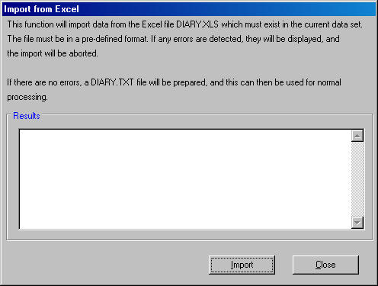

- When the Import button is clicked an attempt is made to process the DIARY.XLS file

- If any errors are found, they are displayed in the Results list box

- If processing is without errors, this is shown in the Results list box, indicating that the DIARY.TXT file has been prepared successfully

- The Close button is then clicked, and then processing (Process button), can be done in the normal manner.

Import Station Fit Responses

4.1 Excel Document

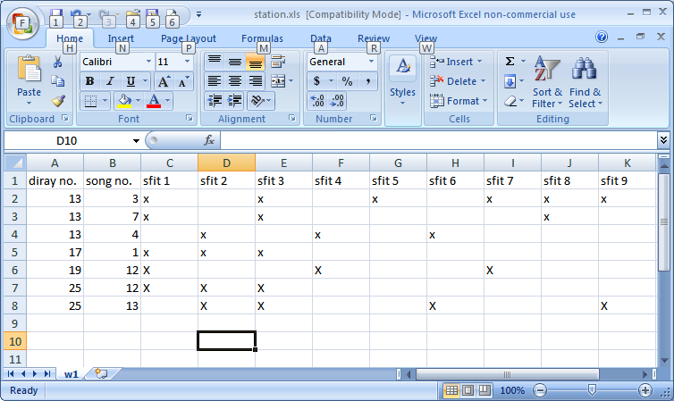

The file STATION.XLS, must exist in the current data set, and it will contain 1 worksheet W1
- Worksheet W1 must exist and will contain the diary number in column 1, song number in column 2 and then the response (x, X, space or -) for each of the 10 station fit stations.

- Row 1 can be used for headings. If row1 is not used for headings, it must be used for diary information

- Diary numbers need not be contiguous, but they must be in ascending sequence. There is no sequence check on song numbers.

- The Worksheet must use the specified name (W1), but it can be either upper or lower case. Worksheets using other names will be ignored

Operation

- Import Station Fit Responses – CATI is initiated in the normal manner

- A new button Import from an Excel file will appear

- If clicked, the following dialog appears

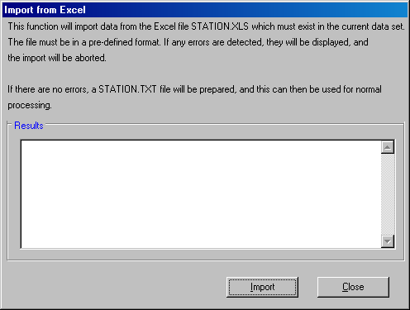

- When the Import button is clicked an attempt is made to process the STATION.XLS file

- If any errors are found, they are displayed in the Results list box

- If processing is without errors, this is shown in the Results list box, indicating that the STATION.TXT file has been prepared successfully

- The Close button is then clicked, and then processing (Process button), can be done in the normal manner.

