General

This document describes the requirements of the Excel file to be used for importing Program Research diaries into the 7-System, and the modified operation of the 7-System to use this Excel file

The Excel File

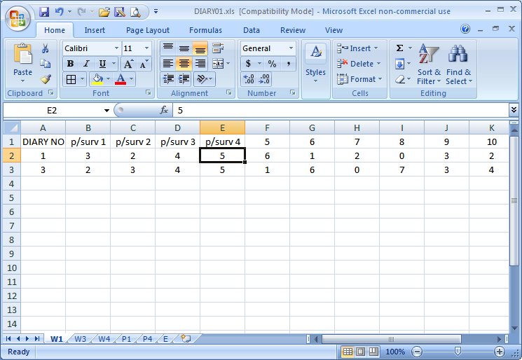

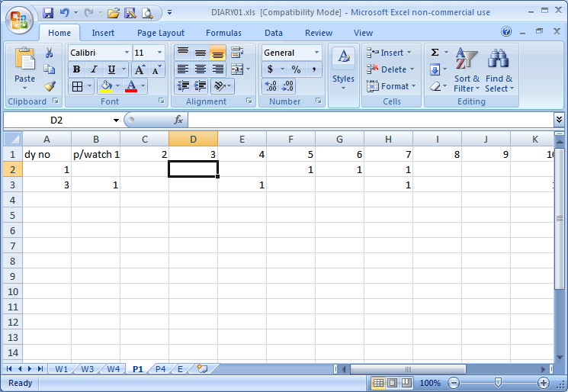

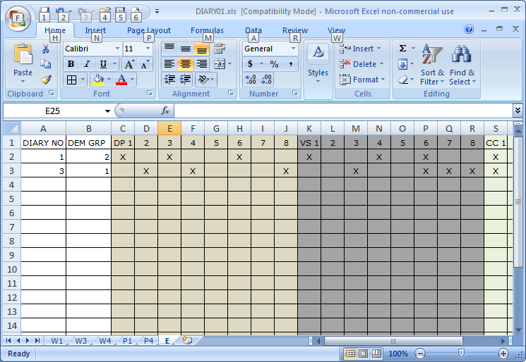

The file DIARYnn.XLS (nn = database number), must exist in the current data set, and it will comprise between 2 and 9 worksheets, specifically –
- Worksheet W1 must exist and will contain the diary number in column 1 and then the response (blank or 1 to 7) to program surveyed 1 to 250 in columns 2 to 251. It will have an optional heading row as row 1 (see example)

- Worksheet W2 will contain the diary number in column 1 and then the response to program surveyed 251 to 500 in columns 2 to 251. It will have an optional heading row as row 1

- Worksheet W3 will contain the diary number in column 1 and then the response to program surveyed 501 to 750 in columns 2 to 251. It will have an optional heading row as row 1

- Worksheet W4 will contain the diary number in column 1 and then the response to program surveyed 751 to 998 in columns 2 to 249. It will have an optional heading row as row 1

- Worksheet P1 is optional and will contain the diary number in column 1 and then the response (1=watched, blank or 0 = not watched) to program watched 1 to 250 in columns 2 to 251. It will have an optional heading row as row 1 (see example)

- Worksheet P2 will contain the diary number in column 1 and then the response (1=watched, blank or 0 = not watched) to program watched 251 to 500 in columns 2 to 251. It will have an optional heading row as row 1 (see example)

- Worksheet P3 will contain the diary number in column 1 and then the response (1=watched, blank or 0 = not watched) to program watched 501 to 750 in columns 2 to 251. It will have an optional heading row as row 1 (see example)

- Worksheet P4 is optional and will contain the diary number in column 1 and then the response (1=watched, blank or 0 = not watched) to program watched 751 to 990 in columns 2 to 240. It will have an optional heading row as row 1 (see example)

- Worksheet E must exist and will contain the diary number in column 1, demographic group in column 2, day parts 1 to 8 in the next 8 columns, viewing spans 1 to 8 in the next 8 columns, and core channels 1 to 8 in the next 8 columns. It will have an optional heading row as row 1. If a daypart etc. is used it is shown as a X or x. If it is not used it is shown as a space or a -

- Either all or none of the worksheets must use row 1 for headings. If row1 is not used for headings, it must be used for diary information

- The same diary number must exist in the same row of each worksheet

- Diary numbers need not be contiguous, but they must be in ascending sequence, without duplicates.

- Only the number of worksheets required to provide the responses need exist e.g., if you have 400 programs surveyed, only worksheets W1, W2 and E (and optionally P1 and P2) need exist.

- Worksheets must use the specified names, but can be either upper or lower case. Worksheets using other names will be ignored

Operation

- Import Program Research Diaries – CATI is initiated in the normal manner

- A new button Import from an Excel file will appear

- If clicked, the following dialog appears

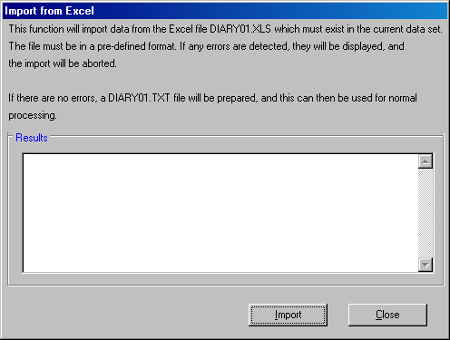

- When the Import button is clicked an attempt is made to process the DIARYnn.XLS file

- If any errors are found, they are displayed in the Results list box

- If processing is without errors, this is shown in the Results list box, indicating that the DIARYnn.TXT file has been prepared successfully

- The Close button is then clicked, and then processing (Process button), can be done in the normal manner.

